EXPERIMENTAL DESIGN OF THE ADAPTIVE BACKSTEPPING CONTROL TECHNIQUE FOR SINGLE PHASE SHUNT ACTIVE POWER FILTERS
ABSTRACT
This paper presents a utilization technique for enhancing the capabilities of dynamic voltage restorers (DVRs). This paper aims to enhance the abilities of DVRs to maintain acceptable voltages and last longer during compensation. Both the magnitude and phase displacement angle of the synthesized DVR voltage are precisely adjusted to achieve lower power utilization. The real and reactive powers are calculated in real time in the tracking loop to achieve better conditions. This technique results in less energy being taken out of the dc-link capacitor, resulting in smaller size requirements. The results from both the simulation and experimental tests illustrate that the proposed technique clearly achieved superior performance. The DVR’s active action period was considerably longer, with nearly five times the energy left in the dc-link capacitor for further compensation compared with the traditional technique. This technical merit demonstrates that DVRs could cover a wider range of voltage sags; the practicality of this idea for better utilization is better than that of existing installed DVRs.

BLOCK DIAGRAM FOR PROPOSED SYSTEM
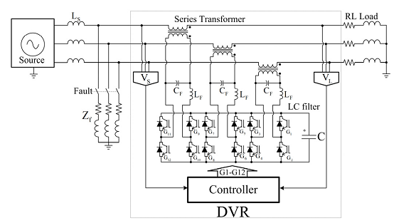
Fig. 1. Circuit diagram model for simulation using MatLab/Simulink.
DESIGNG SOFTWARE AND TOOLS:
MAT LAB /SIMULATION Software and simu power systems tools are used. Mainly control system tools, power electronics and electrical elements tools are used.

